TASK

**PROBLEM STATEMENT -🡪Create a backup of database on every 2nd and 4th friday of each month**

**APPROCH** :

* Need instance which is aws configure and has access of RDS
* We need to write a script that will take snapshot of DB instance
* After that we have to run that script on every 2nd and 4th Friday of month

STEP

STEP 1 Get Access key and secret key of user who has sufficient authority to work with RDS

STEP 2 Launch the instance. I am using ubuntu for this task

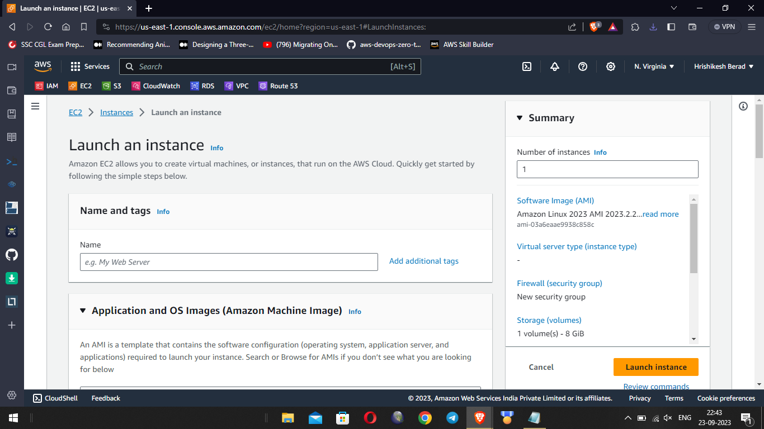

STEP 3 Get ssh access of instance using public Ip of instance [note: make sure you have private key available in folder where you are taking ssh of instance]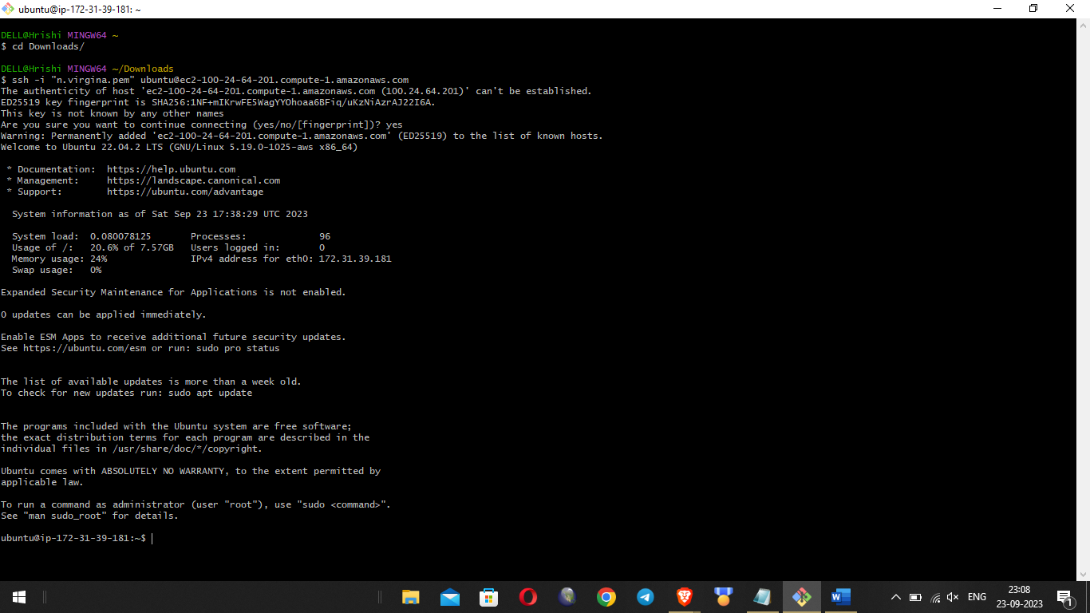

STEP 4 install aws cli in it using command sudo apt-get update && sudo apt-get install awscli

STEP 5 After this we need to configure aws in our instance to do this run command “aws configure” , enter your access key and secret key

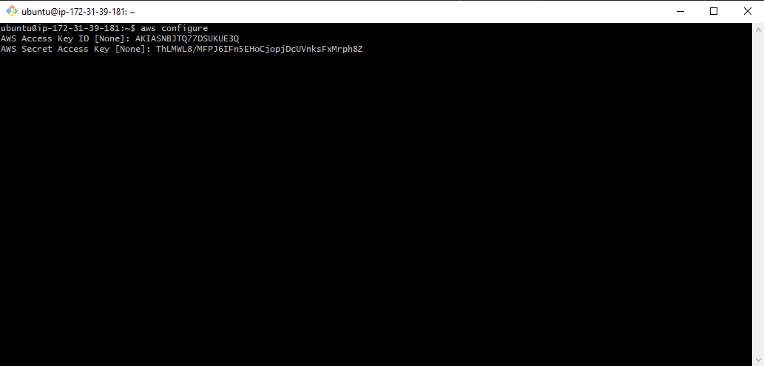

STEP 6 Create a shell script to take snapshot of RDS instance

#!/bin/bash

# Replace with your RDS instance identifier and AWS region

RDS_INSTANCE_IDENTIFIER="database-1"

AWS_REGION="us-east-1 "

SNAPSHOT_IDENTIFIER="Snapshot-$(date +\%Y\%m\%d\%H\%M\%S)"

aws rds create-db-snapshot --db-instance-identifier "$RDS_INSTANCE_IDENTIFIER" --db-snapshot-identifier "$SNAPSHOT_IDENTIFIER" --region "$AWS_REGION"

# Print a message

echo "RDS snapshot created: $SNAPSHOT_IDENTIFIER"

STEP 7 Make it executable by running chmod +x filename

STEP 8 Create a crontab job that will run this file on every 2nd and 4th Friday of month

# Run on every 2nd and 4th Saturday of the month

0 0 * * 6 [ "$(date +\%d)" -ge 08 -a "$(date +\%d)" -le 14 ] && /root/ backup_rds.sh

0 0 * * 6 [ "$(date +\%d)" -ge 22 -a "$(date +\%d)" -le 28 ] && /root/backup_rds.sh

NOTE : just to capture and see that backup is created I have run the script

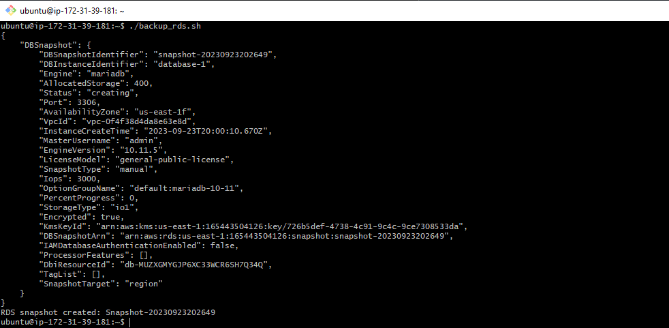



SNAPSHOT HAS CREATED SUCCESSFULLY